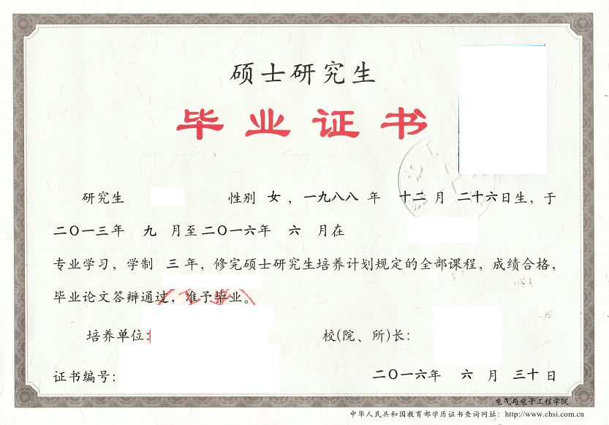
HUBEI UNIVERSITY OF TECHNOLOGY

POSTGRADUATE DIPLOMA
Certificate No: ************
This is to certify that ******, female, born on December 26,1988, majoring in****** of this university from September 2013 to June 2016, has successfully fulfilled all curriculums of the three-year postgraduate program of study, and passed the examinations. Hereby she is allowed to graduate.

President: ******
Hubei University of Technology
Issued Date: June 30,2016

注：上传利用人证书，标红部分根据实际内容填写
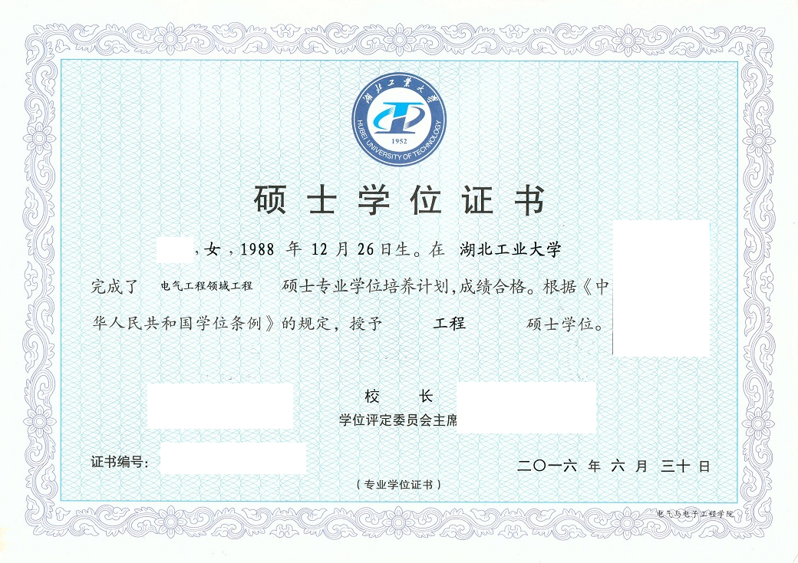
CERTIFICATE FOR THE MASTER'S DEGREE

Certificate No: ************
This is to certify that ******, female, born on December 26,1988, majoring in****** of this university, has completed a master's degree in Engineering Training Program , qualified success.
Upon the examination and verification in conformity with the Regulations of Academic Degrees of the People's Republic of China, she is thereby granted the Master’s Degree of Engineering.

President of Hubei University of Technology: ******
Chairman of Degree Evaluation Committee: ******
Issued Date: June 30,2016
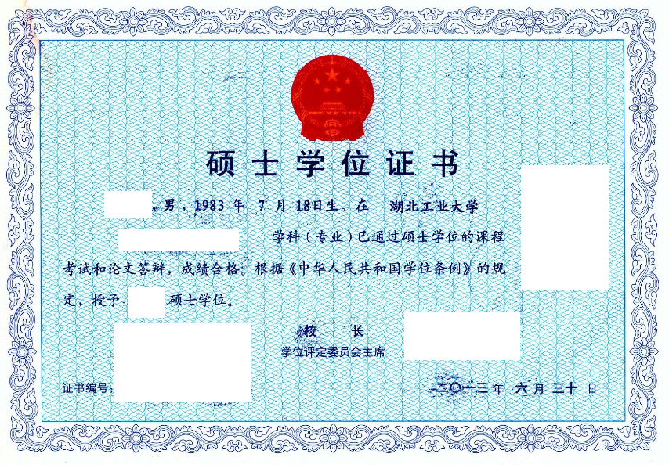
CERTIFICATE FOR THE MASTER'S DEGREE

Certificate No: ************
This is to certify that ***, male, born on July 18,1983, majoring in ******* of this university, has passed all examinations and the oral defense of Master dissertation .
Upon the examination and verification in conformity with the Regulations of Academic Degrees of the People's Republic of China, he is thereby granted the Master’s Degree of ******.

President of Hubei University of Technology: ******
Chairman of Degree Evaluation Committee: ******
Issued Date: June 30,2013

