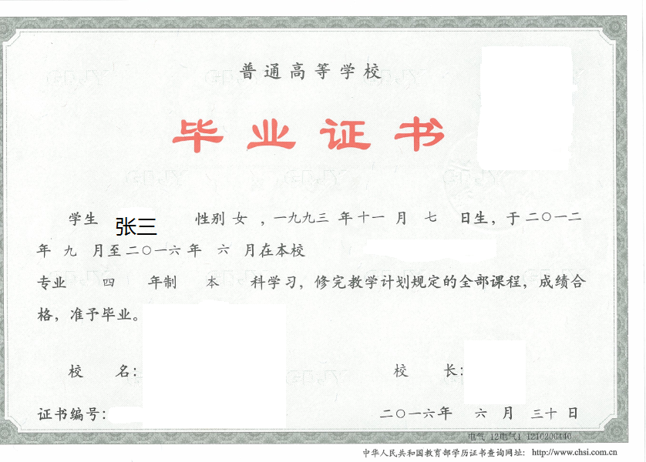

CERTIFICATE FOR GRADUATION
HUBEI UNIVERSITY OF TECHNOLOGY
Certificate No: *****************
This is to certify that Zhang San, female/male, born on November 7,1993, majoring in （Major） of this university from September 2012 to June 2016, has successfully fulfilled all curriculums of the Four-year undergraduate program of study, and passed the examinations. Hereby she/he is allowed to graduate.

President:*****

Hubei University of Technology
Issued Date: June 30,2016

注：上传利用人证书，内容仅修改红色部分
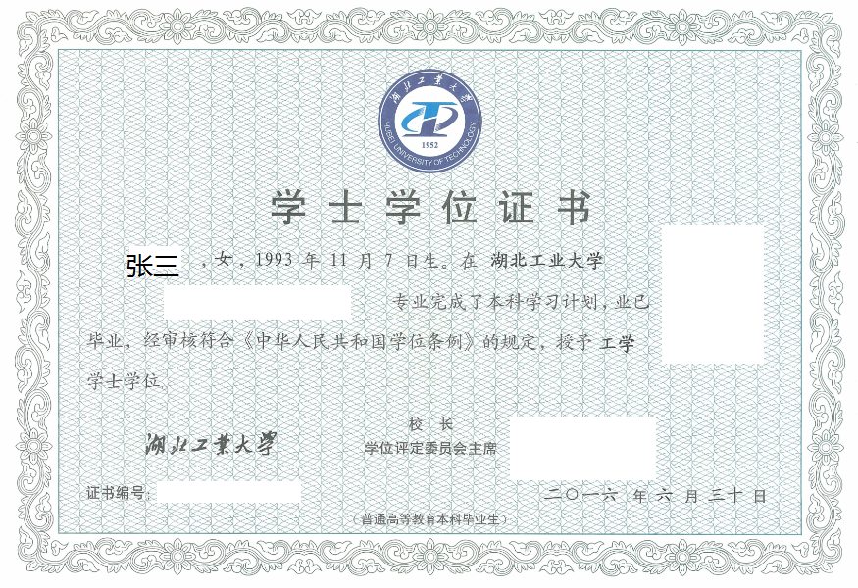

CERTIFICATE FOR THE BACHELOR'S DEGREE
Certificate No: **************
This is to certify that Zhang San, female/male, born on November 7,1993, majoring in （Major） of this university, has successfully fulfilled all curriculums of the Four-year undergraduate program of study, and has graduated.
Upon the examination and verification in conformity with the Regulations of Academic Degrees of the People's Republic of China, she/he is thereby granted the Bachelor’s Degree of Engineering.

President of Hubei University of Technology: *****
Chairman of Degree Evaluation Committee: *****
Issued Date: June 30, 2016

