STUDENT’S ACADEMIC RECORD
STUDENT’S NUMBER: *********
Name: ********* School of: ********* Major: ********* (College Diploma)
Length of schooling: 3 years Date of Entrance: September, **** Date of Tabling: MM/DD/2018
NO. | Course | Credit | First  Academic Year |  | Second  Academic Year |  | Third  Academic Year
NO. | Course | Credit | First  Semester | Second  Semester | Third  Semester | Fourth  Semester | Fifth  Semester | Sixth  Semester
1
2
3
4
5
6
7
8
9
10
11
12
13
14
15
16
17
18
19
20
21
22
23
24
25
26
27
28
29
30
31
32
33
34
35
36

学生学籍成绩表
学 号：*********
姓 名: ********* 学 院: ********* 专 业: *********专
学 制: 3年 入学日期：****.9 制表日期：2018/月/日
序号 | 课程 | 学分 | 第一学年 |  | 第二学年 |  | 第三学年
序号 | 课程 | 学分 | 第一学期 | 第二学期 | 第三学期 | 第四学期 | 第五学期 | 第六学期
1
2
3
4
5
6
7
8
9
10
11
12
13
14
15
16
17
18
19
20
21
22
23
24
25
26
27
28
29
30
31
32
33
34
35
36

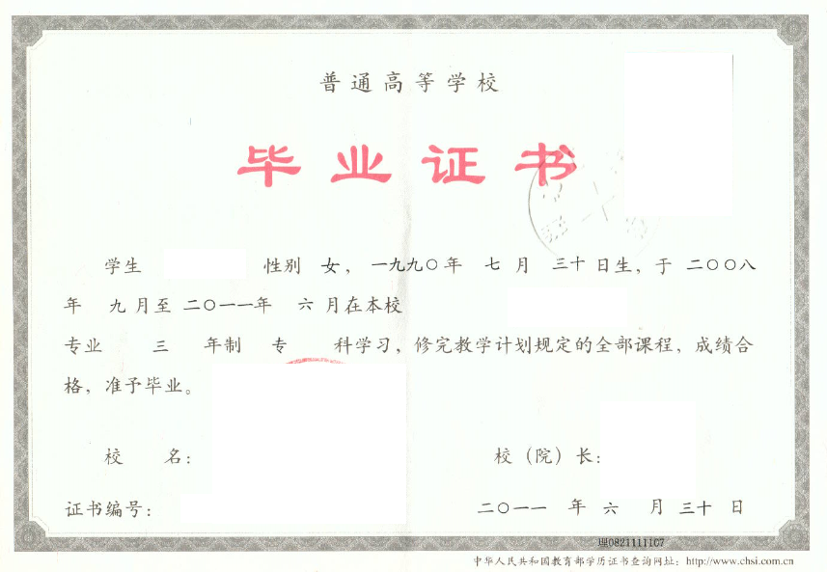

CERTIFICATE FOR GRADUATION
HUBEI UNIVERSITY OF TECHNOLOGY
Certificate No: **************
This is to certify that **************, female, born on July 30,1990, majoring in ************** of this university from September 2008 to June 2011, has successfully fulfilled all curriculums of the Three-year college program of study, and passed the examinations. Hereby she is allowed to graduate.

President: **************

Hubei University of Technology
Issued Date: June 30,2011

注：上传利用人证书，标红部分根据实际情况填写

