证明
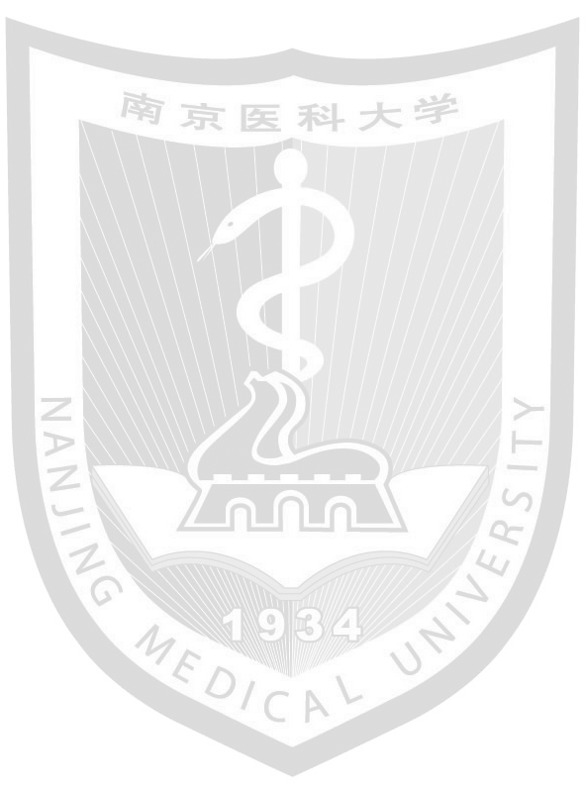
兹证明XXXX，女， 1995年10月3日生，于2014年9月至2019年6月在南京医科大学预防医学本科专业就读，学号为XXXXXX。该生在校期间的课程算术平均分为。
特此证明
南京医科大学教务科
2018年12月5日

Certificate
This is to certify that YXXXXX, female, born on October 3, 1995, has studied as an undergraduate student in Nanjing Medical University from September 2014 to June 2019 with the major of Preventive Medicine and the student ID of XXXXX. Her curriculum arithmetic average score is 3.27 out of 5.
Academic Affairs Office of Nanjing Medical University
December 5, 2018
78.74/100 2.76/5
11/24

