CERTIFICATE OF BACHELOR’S DEGREE

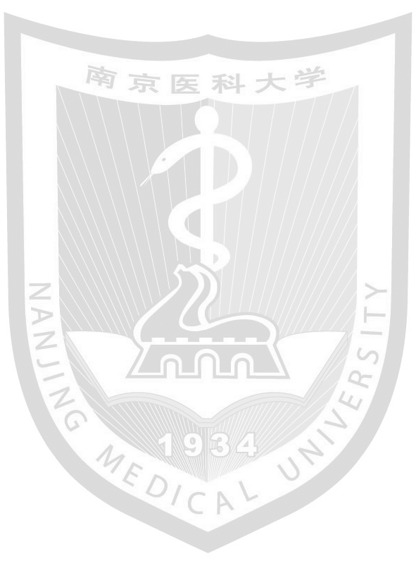
This is to certify that XXX_{(姓名)}, X_{(性别)}, born on XXXX_{(出生年月日，例如December 18, 1992)}, studied XXXX_{(专业名称)} from XXXX_{(入学年月，例如September 2011)} to XXXX _{(毕业年月，例如June 2016)} (Length of Schooling: X years)_{(专业对应学制，4或5年)} at this university, has completed all the courses prescribed in the undergraduate teaching program and has fulfilled the requirements for graduation. Through the deliberation of Nanjing Medical University Academic Degree Evaluation Committee, the Bachelor of X(学位类别，例如：Medicine, Science, Engineering, Arts, Management) degree is hereby conferred.

XXX_{(学术委员会主席姓名)}
Chairman of Academic Degree Evaluation Committee
Nanjing Medical University
Degree Certificate No.: XXXXXXXXXXXXXXXX_{(学士学位证书编号)}
Date Issued: XXXX _{(学位证书颁发日期，例如June 30, 2016)}

Academic Affairs Office of Nanjing Medical University
XXXX _{(证明出具日期，例如October 31, 2019)}

