CERTIFICATE OF GRADUATION

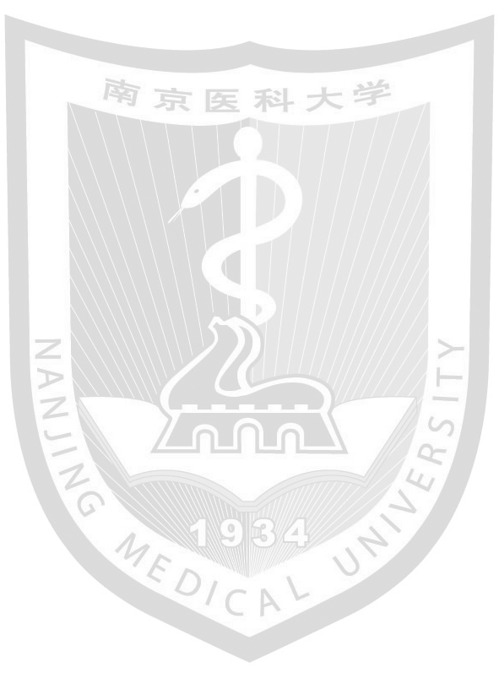
This is to certify that XXX_{(姓名)}, X_{(性别)}, born on XXXX_{(出生年月日，例如December 18, 1992)}, studied XXXX_{(专业名称)} from XXXX_{(入学年月，例如September 2011)} to XXXX _{(毕业年月，例如June 2016)} (Length of Schooling: X years)_{(专业对应学制，4或5年)} at this university, has completed all the courses prescribed in the undergraduate teaching program and has fulfilled the requirements for graduation. Certificate of graduation is hereby granted.

XXX_{(校长姓名)}
President of Nanjing Medical University
Graduation Certificate No.: XXXXXXXXXXXXXXXX_{(毕业证书编号)}
Date Issued: XXXX _{(毕业证书颁发日期，例如June 30, 2016)}

Academic Affairs Office of Nanjing Medical University
XXXX _{(证明出具日期，例如October 31, 2019)}

