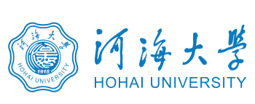

This is to certify that
the Degree Awarding Committee of Hohai University
hereby confers on

JANG LONG

was awarded the Degree of
MASTER
in
Environmental Science and Engineering

with all its rights, privileges and honors
on
June 19, 2018

No. 1029432018000600 President: Xu Hui

This is to certify that
JANG LONG
born on September 18, 1993
has fulfilled all the requirements
and achieved the prescribed standard for
Master degree in Environmental Science and Engineering
from September 2015 to June 2018.
President:Xu Hui
No. 102941201802000600 June 19, 2018

