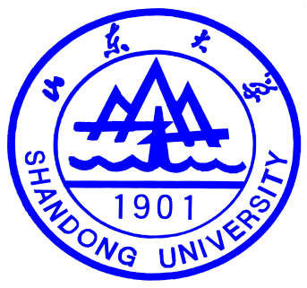
ACADEMIC RECORD OF SHANDONG UNIVERSITY

Name: Student No.: Depart:
Specialty: Period of Study： Length of Schooling : 4
First Year ( ) |  |  |  |  | Second Year ( )
Course Title | First Term |  | Second Term |  | Course Title | First Term |  |  |  | Second Term
Course Title | Credits | Scores | Credits | Scores | Course Title | Credits |  | Scores |  | Credits |  | Scores
Third Year ( ) |  |  |  |  | Fourth Year ( )
Course Title | First Term |  | Second Term |  | Course Title | First Term |  |  | Second Term
Course Title | Credits | Scores | Credits | Scores | Course Title | Credits | Scores |  | Credits |  | Scores
Notes: The results of examinations are given in hundred-mark system (0-100); the results of tests are given in five or two ratings: A(100-90), B(89-80), C(79-70), D(69-60), E(59-0) ; pass(100-60) ,fail(59-0). |  |  |  |  | Stamp:  Archives of SDU

