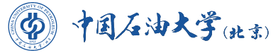
China University of Petroleum-Beijing

Certificate of Graduation

June 28th, 2018
This is to certify that Mr./Ms. ZHANG Weimin, born on Oct. 10, 1999, has studied at China University of Petroleum-Beijing, as a four-year fulltime undergraduate on the program of Mechanical Design & Manufacturing and Their Automation from September 2007 to June 2011. Upon completing and passing all the required courses of the program, he/she is hereby awarded this certificate of graduation.
Certificate No.114141200000000000

President

