说明：
1、专业名称请以英文成绩单（咨询主楼214）中的翻译为准；
2、根据中文证书内容，把模板中红色部分填好，去掉括号内容及本段说明后自行打印，至主楼206盖章即可。
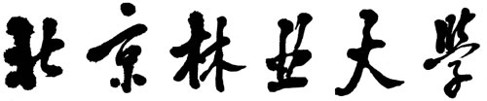
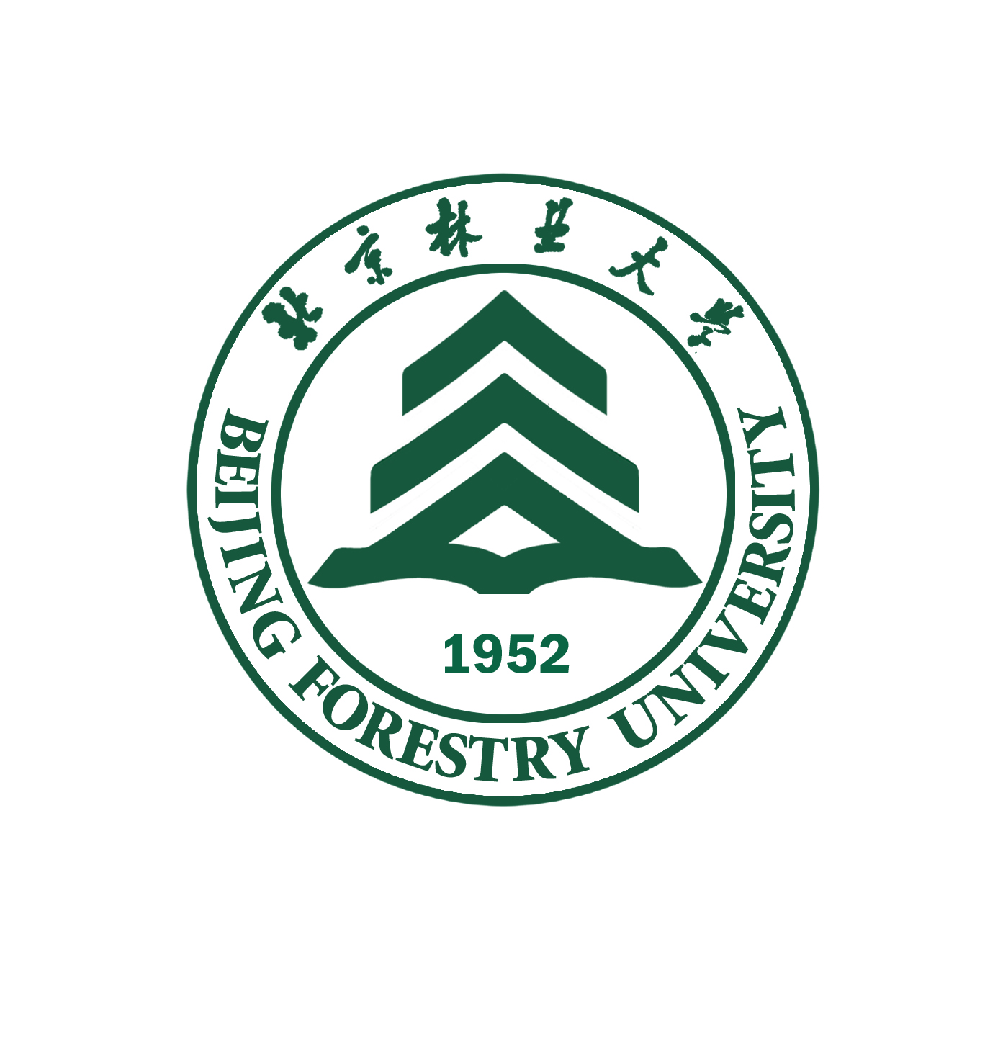
BEIJING FORESTRY UNIVERSITY

DIPLOMA
This is to certify that ×××（姓名）, Male or Female（性别）, born on Apr. 26, 1985（出生日期） , has studied in the College of Biological Sciences and Biotechnology（学院）, Beijing Forestry University with the major of Processing and Storage of Agricultural products（专业） from September 2006 to July 2020. Upon completing and passing all the required courses of the 3-year master program, he or she is granted graduation.

Beijing Forestry University
President of Beijing Forestry University: Mr. ×××（校长名）
July 1, 2010（毕业证书上的日期）
Registration No.: ×××（填写毕业证书编号 100221……开头）

