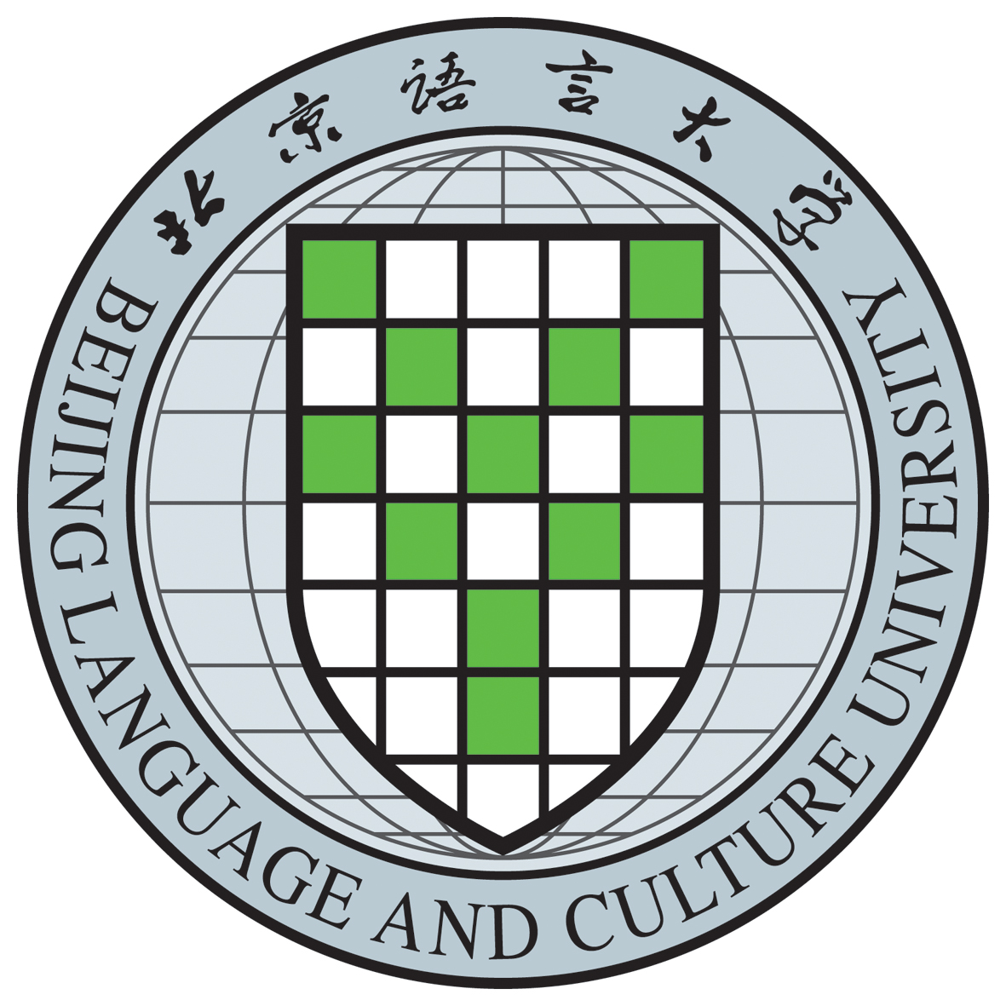

CERTIFICATE OF BACHELOR’S DEGREE
(Translation)
This is to certify that Fang Ruoshui, female, born on March 4，1988, has studied in School of International Business of Beijing Language and Culture University with a specialty in English from September 2006 to July 2010 and is granted graduation upon completing and passing all the required courses of the four-year undergraduate program. In accordance with The Regulations of the People’s Republic of China on Academic Degrees, the Degree Awarding Committee of the University hereby confers upon Fang Ruoshui the degree of BACHELOR OF ARTS with all its rights and privileges.

Certificate number: 100324xxxxx
（注：标黄处需根据自己中文学位证上的信息填写，需保持完全一致，否则无效。因每届学生情况不同，不可统一规范。请认证时删去此段话，谢谢！）

President：Liu Li
Chairman of Degree Awarding Committee,
Beijing Language and Culture University
Issued on July 1，2010

