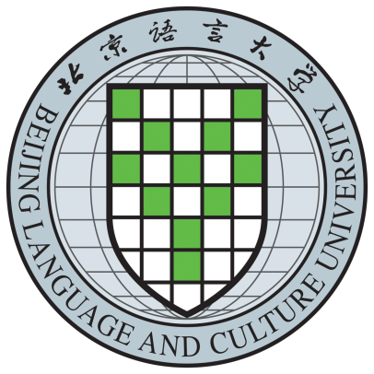

CERTIFICATE OF MASTER’S DEGREE
(Translation)
This is to certify that Fang Ruoshui, female, born on March 4，1988, has studied Chinese Language and Literature(M.A.) at Beijing Languageand Culture University and is granted graduation upon completing and passing all the required courses of the three-year graduate program. In accordance with The Regulations of the People’s Republic of China on Academic Degrees, the Degree Awarding Committee of the University hereby confers upon Fang Ruoshui the degree of MASTER OF ARTS with all its rights, privileges and honors.

Certificatenumber：10032xxxxxxxx

Cui Xiliang
Chairman of Degree Awarding Committee
Beijing Languageand Culture University
Issued on July 1，2010
注：2017年及以后毕业学生 President：Liu Li

